########################### Katalon BDD Framework ########################

1. First Install the Katalon 7.2 version and create the new project.
2. Create one folder under Include 🡪features to create feature file.

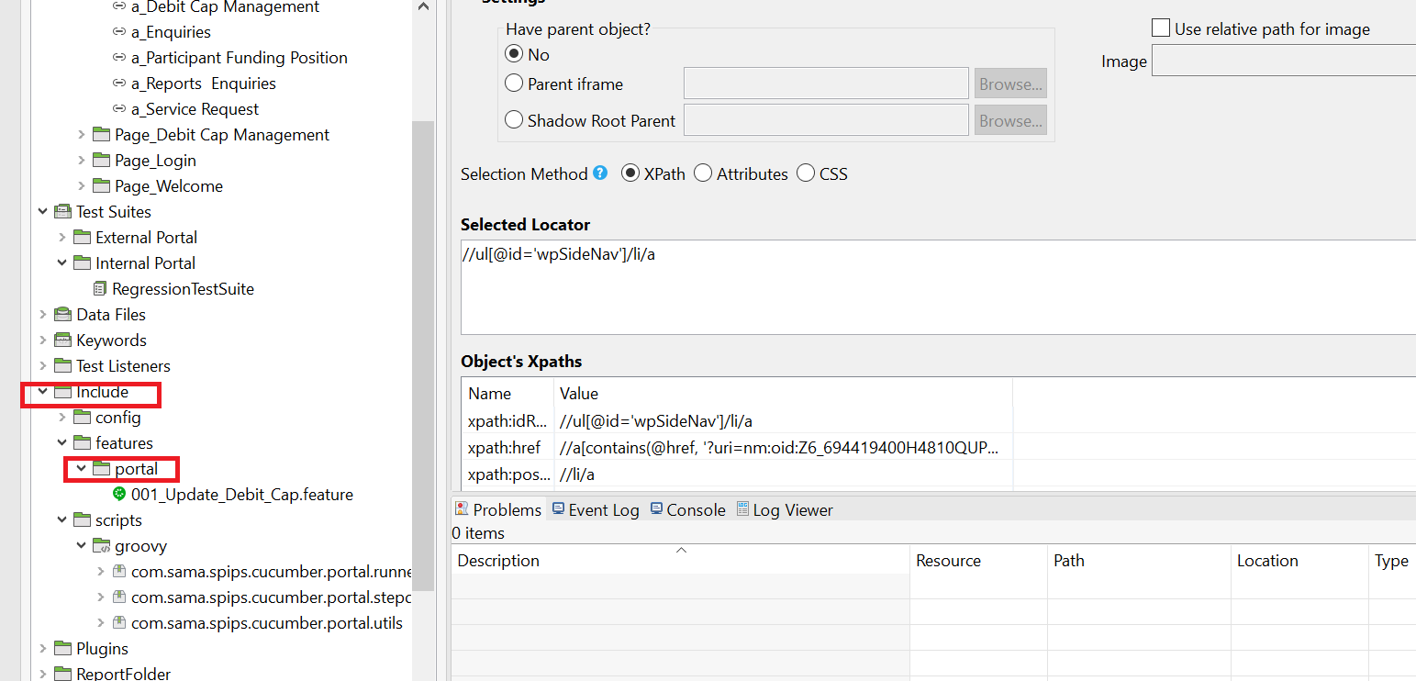

1. Create three package under Include🡪scripts🡪groovy. Attached Screenshot for reference

* com.sama.spips.cucumber.portal.runners
* com.sama.spips.cucumber.portal.stepdefs
* com.sama.spips.cucumber.portal.utils

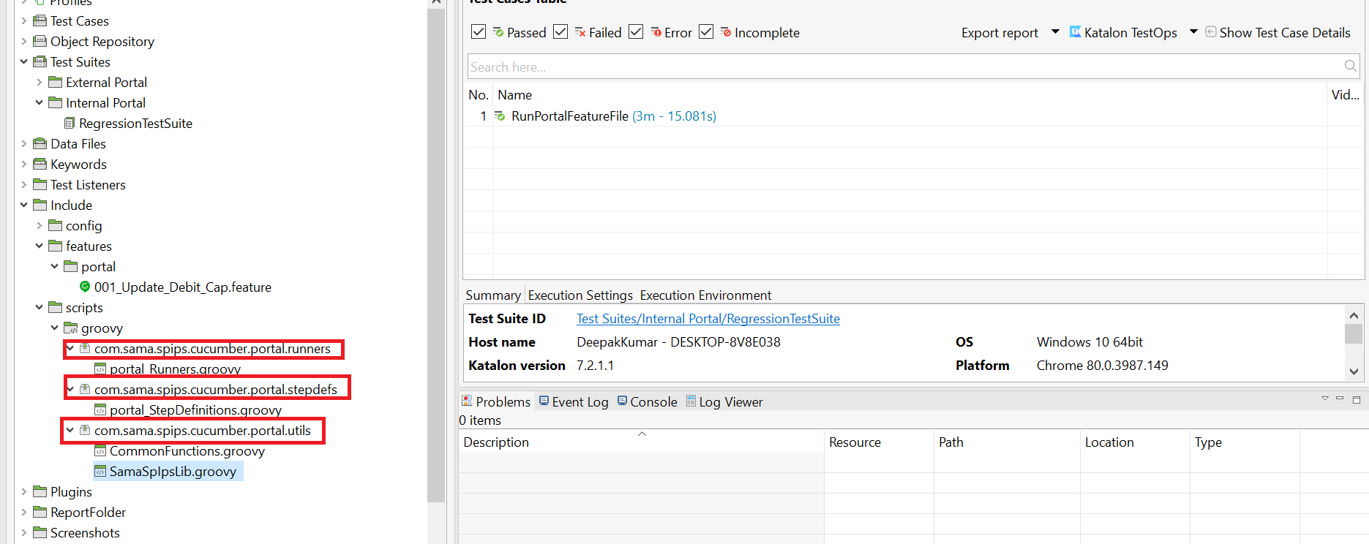

1. Then create below step definition under each package. Attached Screenshot for reference.

com.sama.spips.cucumber.portal.runners

* portal_Runners

com.sama.spips.cucumber.portal.stepdefs

* portal_StepDefinitions

com.sama.spips.cucumber.portal.utils

* CommonFunctions
* SamaSpIpsLib

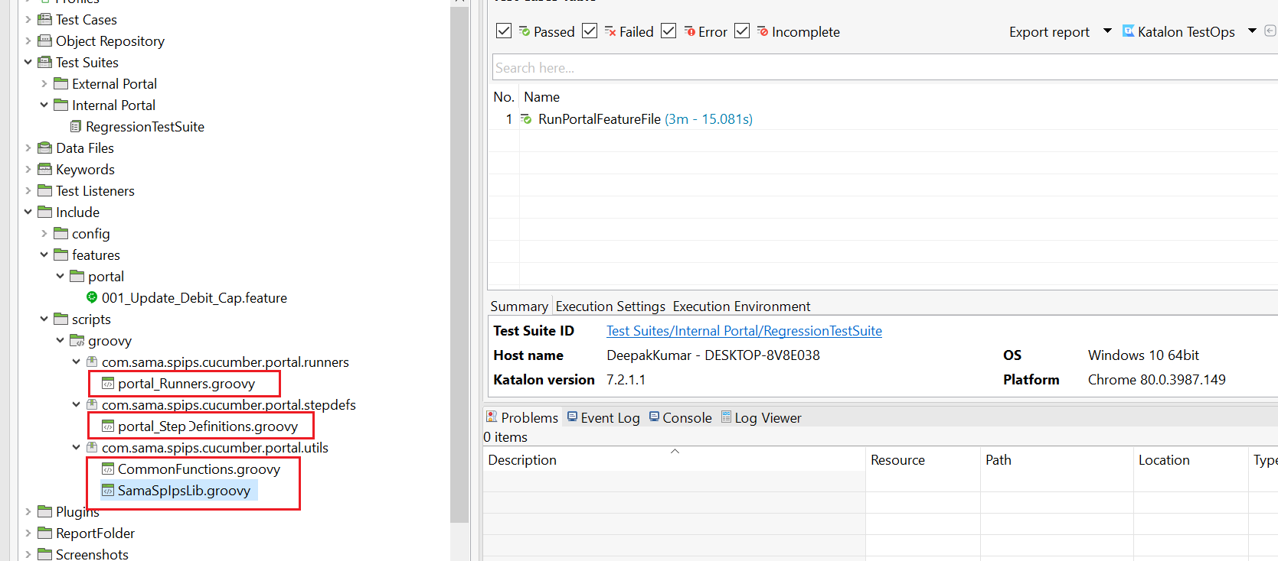

1. Create one folder under Object Repository to store all web elements using ‘Spy Web’

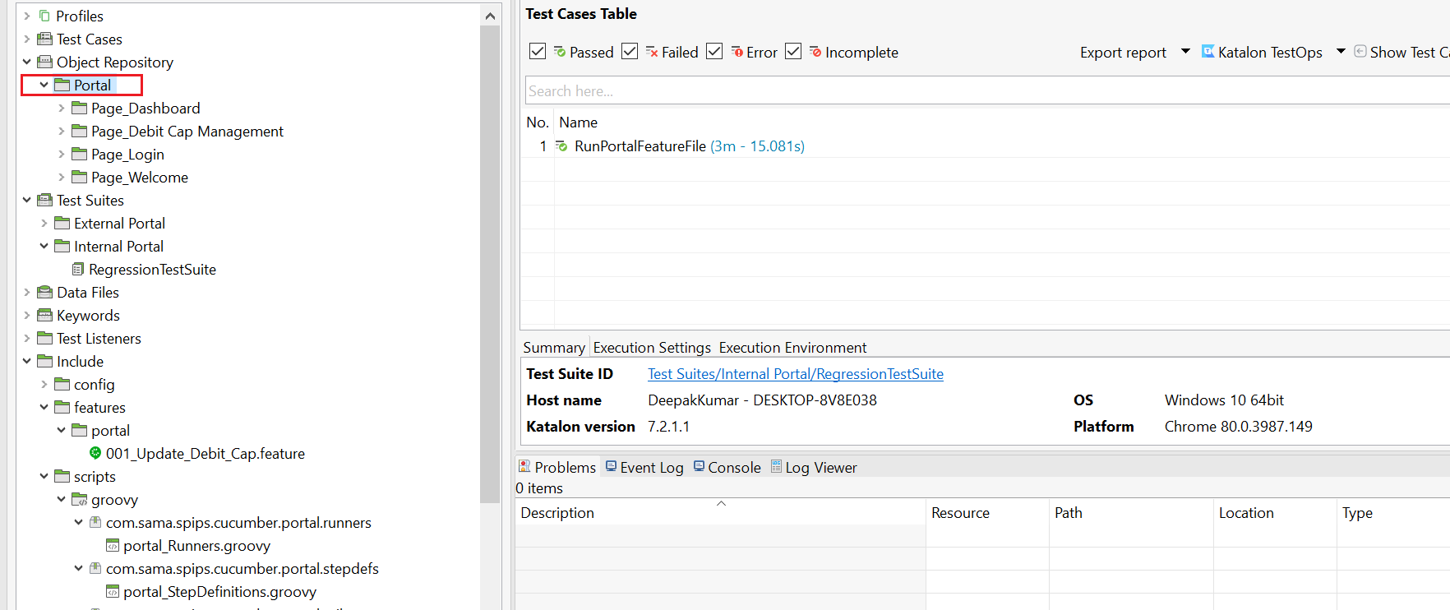

1. hahhahaha